General Star Polygon
# Source: AI Source: Provided by: [Data Path: Persons Table -> ID Column: 1, Name_En Column: Motasem Essam] -> From: [ChatGPT] on [7/25/2026]
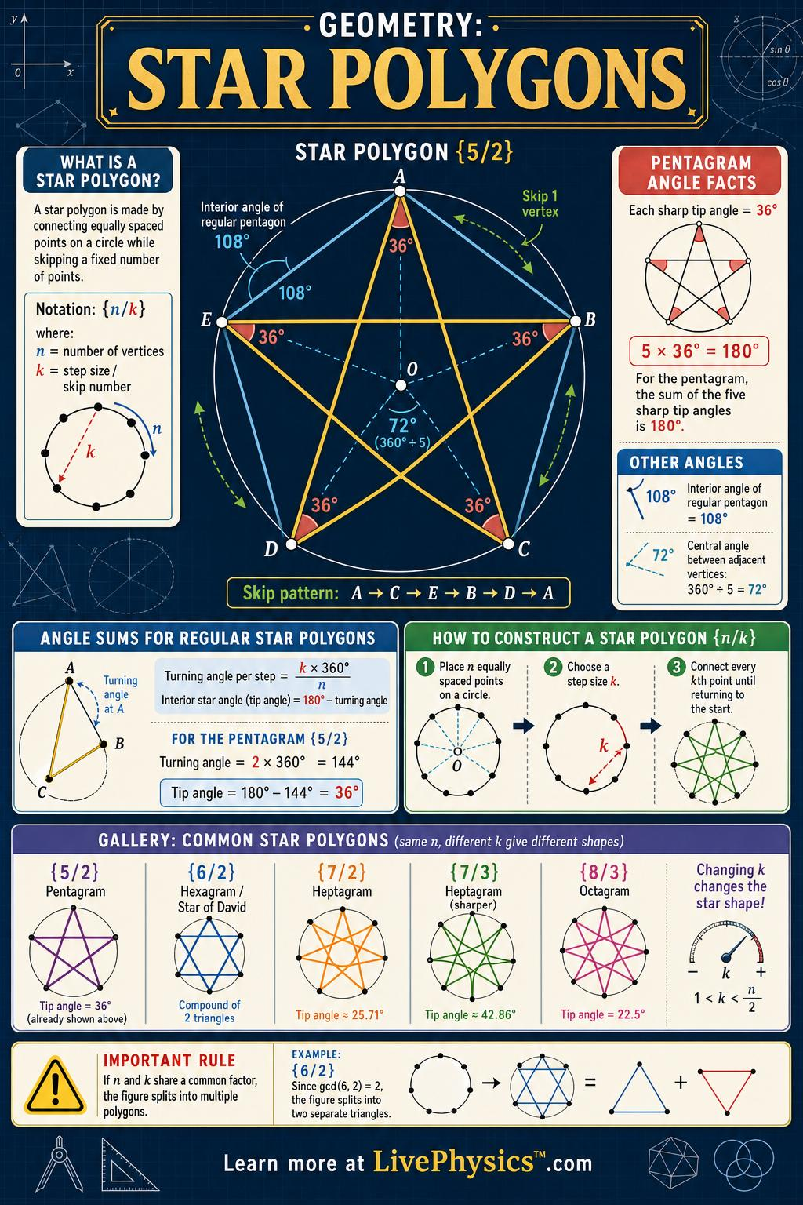
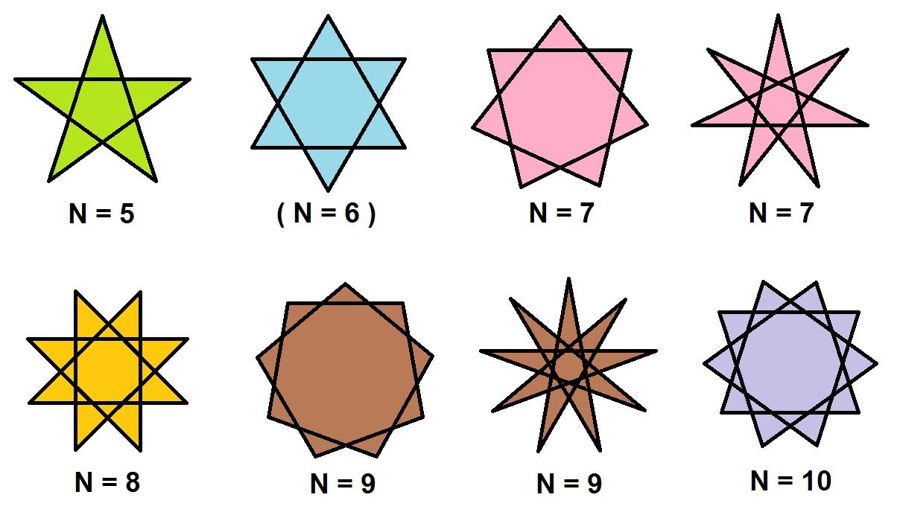
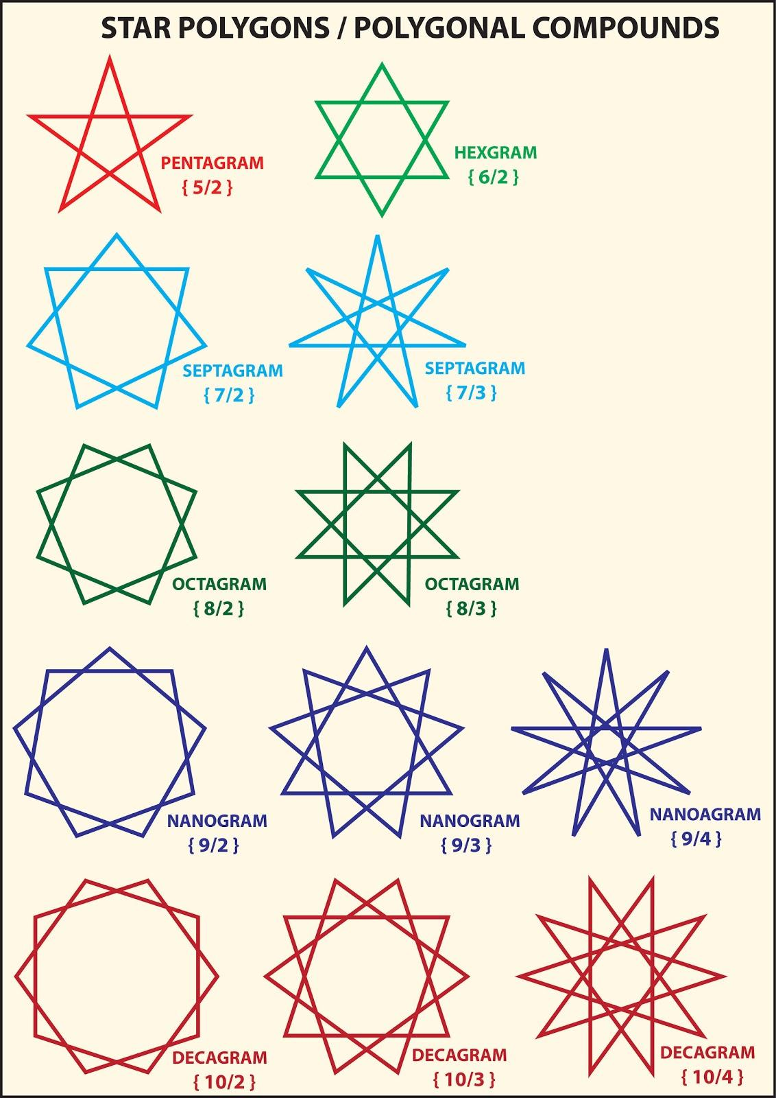
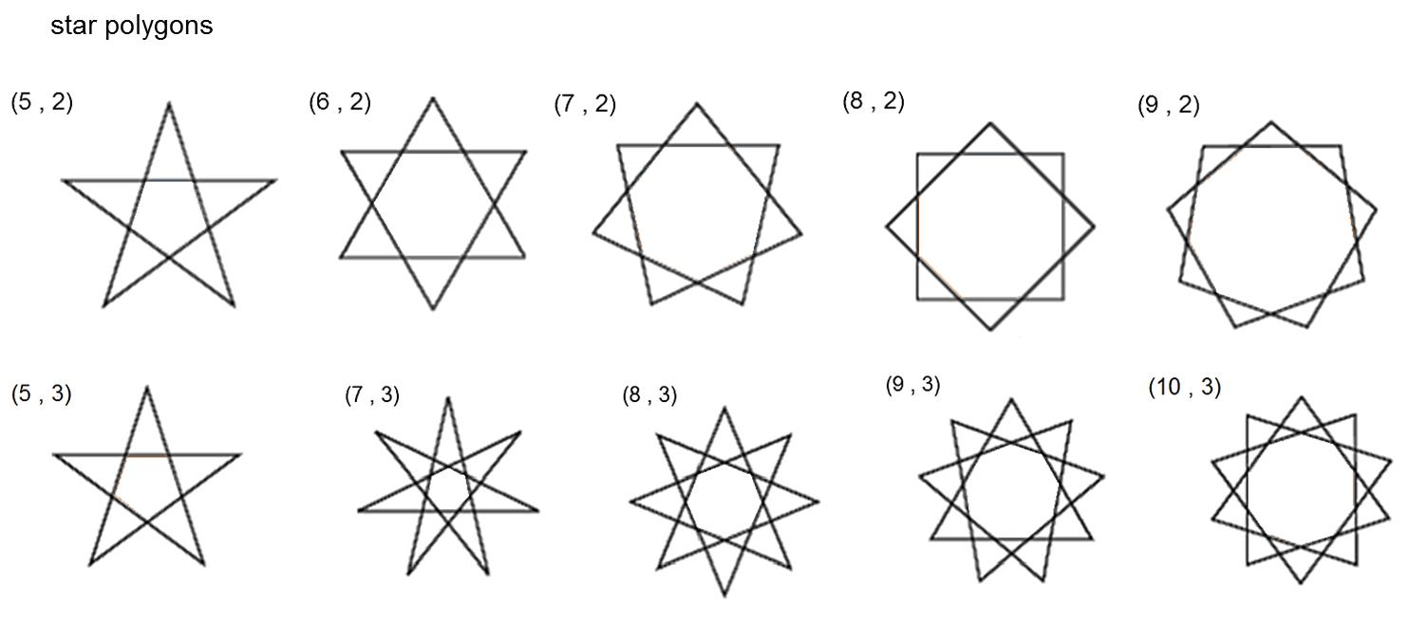
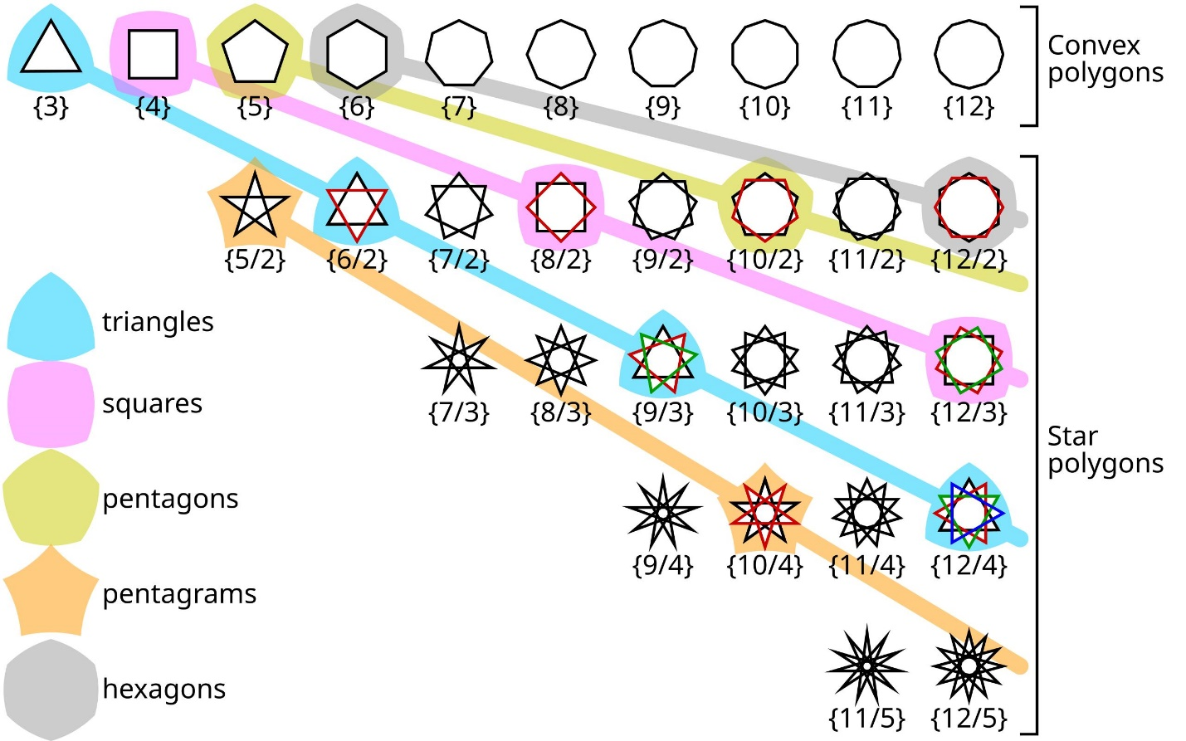

Definition
# Source: AI Source: Provided by: [Data Path: Persons Table -> ID Column: 1, Name_En Column: Motasem Essam] -> From: [ChatGPT] on [7/25/2026]
A General Star Polygon is a self-intersecting polygon formed by connecting the vertices of a regular polygon in a non-consecutive pattern.
A regular star polygon is commonly represented using Schläfli notation:
$$\boxed{\left\{n/k\right\}}$$
where:
- $n$= number of vertices of the underlying regular polygon.
- $k$= step size, indicating how many vertices are advanced when drawing each new edge.
- The polygon is formed by repeatedly connecting vertices according to this step.
For example:
$$\left\{5/2\right\}$$
is the pentagram, while:
$$\left\{7/2\right\}, \left\{7/3\right\}$$
are heptagrams, and:
$$\left\{8/3\right\}$$
is an octagram.

Purpose
# Source: AI Source: Provided by: [Data Path: Persons Table -> ID Column: 1, Name_En Column: Motasem Essam] -> From: [ChatGPT] on [7/25/2026]
General Star Polygons are useful for:
- Classifying self-intersecting polygons.
- Studying regular polygon constructions.
- Understanding rotational and reflection symmetry.
- Studying geometric intersections.
- Understanding Schläfli notation.
- Creating star-shaped geometric patterns.
- Connecting regular polygons with more complex geometric figures.

Fundamental Elements
# Source: AI Source: Provided by: [Data Path: Persons Table -> ID Column: 1, Name_En Column: Motasem Essam] -> From: [ChatGPT] on [7/25/2026]
A regular star polygon is characterized by:
- $n$ vertices.
- A step size $k$.
- Straight edges.
- Self-intersections.
- Rotational symmetry.
- Reflection symmetry in the regular case.
- An underlying regular $n$-gon.
The two most important parameters are therefore:
$$\boxed{n=\text{number of vertices}}$$
and
$$\boxed{k=\text{step size}}$$

Mathematical Representation
# Source: AI Source: Provided by: [Data Path: Persons Table -> ID Column: 1, Name_En Column: Motasem Essam] -> From: [ChatGPT] on [7/25/2026]
The standard representation is:
$$\boxed{\left\{n/k\right\}}$$
Example
For:
$$\left\{7/2\right\}$$
we have:
$$n=7$$
and:
$$k=2$$
Therefore, it has seven vertices and connects every second vertex of the underlying regular heptagon.

Construction
# Source: AI Source: Provided by: [Data Path: Persons Table -> ID Column: 1, Name_En Column: Motasem Essam] -> From: [ChatGPT] on [7/25/2026]
To construct a regular star polygon:
Step 1: Draw a regular $n$-gon
Place $n$equally spaced vertices on a circle.
Step 2: Choose a step size $k$
Choose the number of vertices to advance at each step.
Step 3: Connect the vertices
Starting from one vertex, repeatedly move $k$positions around the polygon and connect the current vertex to the new vertex.
Step 4: Continue until the starting vertex is reached
The resulting figure is a star polygon if the construction produces a self-intersecting single path.

Example: Pentagram
# Source: AI Source: Provided by: [Data Path: Persons Table -> ID Column: 1, Name_En Column: Motasem Essam] -> From: [ChatGPT] on [7/25/2026]
Take a regular pentagon:
$$A,B,C,D,E$$
Using step size $k=2$:
$$A→C→E→B→D→A$$
This produces:
$$\boxed{\left\{5/2\right\}}$$
which is the pentagram.

Example: Heptagram
# Source: AI Source: Provided by: [Data Path: Persons Table -> ID Column: 1, Name_En Column: Motasem Essam] -> From: [ChatGPT] on [7/25/2026]
For:
$$\left\{7/2\right\}$$
the construction is:
$$A→C→E→G→B→D→F→A$$
This produces a seven-pointed star polygon.
Another possible heptagram is:
$$\boxed{\left\{7/3\right\}}$$
which uses a different step size and therefore creates a different crossing pattern.

Example: Octagram
# Source: AI Source: Provided by: [Data Path: Persons Table -> ID Column: 1, Name_En Column: Motasem Essam] -> From: [ChatGPT] on [7/25/2026]
For:
$$\left\{8/3\right\}$$
the construction connects every third vertex of a regular octagon.
Thus:
$$\boxed{\left\{8/3\right\}}$$
is a regular eight-vertex star polygon.

The Greatest Common Divisor
# Source: AI Source: Provided by: [Data Path: Persons Table -> ID Column: 1, Name_En Column: Motasem Essam] -> From: [ChatGPT] on [7/25/2026]
An important condition is:
$$\boxed{gcd⁡\left(n , k\right)=1}$$
If:
$$gcd⁡\left(n , k\right)=1$$
the construction produces one continuous star polygon that visits all $n$vertices.
If:
$$gcd⁡\left(n , k\right)>1$$
the construction splits into multiple separate cycles rather than one continuous star polygon.
Example
Consider:
$$\left\{8/2\right\}$$
Since:
$$gcd⁡\left(8 , 2\right)=2$$
the construction does not produce one continuous octagram.
Instead, it produces two separate cycles.

Number of Components
# Source: AI Source: Provided by: [Data Path: Persons Table -> ID Column: 1, Name_En Column: Motasem Essam] -> From: [ChatGPT] on [7/25/2026]
For the general construction $\left\{n/k\right\}$, the number of separate cycles is:
$$\boxed{gcd⁡\left(n , k\right)}$$
Therefore, the construction is a single polygon when:
$$\boxed{gcd⁡\left(n , k\right)=1}$$

Rotational Symmetry
# Source: AI Source: Provided by: [Data Path: Persons Table -> ID Column: 1, Name_En Column: Motasem Essam] -> From: [ChatGPT] on [7/25/2026]
A regular star polygon constructed from $n$equally spaced vertices has rotational symmetry of order:
$$\boxed{n}$$
The smallest non-zero rotation is:
$$\boxed{θ=\frac{{360}^{∘}}{n}}$$
Example
For a seven-pointed star:
$$θ=\frac{{360}^{∘}}{7} \\ θ≈{51.43}^{∘}$$
For an eight-pointed star:
$$θ=\frac{{360}^{∘}}{8} \\ θ={45}^{∘}$$

Reflection Symmetry
# Source: AI Source: Provided by: [Data Path: Persons Table -> ID Column: 1, Name_En Column: Motasem Essam] -> From: [ChatGPT] on [7/25/2026]
A regular star polygon also has reflection symmetry.
For the regular form, the number of reflection axes is generally:
$$\boxed{n}$$
Thus:
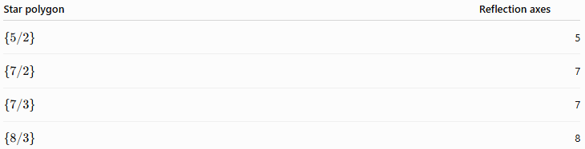
Star polygon | Reflection axes
$$\left\{5/2\right\}$$ | 5
$$\left\{7/2\right\}$$ | 7
$$\left\{7/3\right\}$$ | 7
$$\left\{8/3\right\}$$ | 8

Perimeter
# Source: AI Source: Provided by: [Data Path: Persons Table -> ID Column: 1, Name_En Column: Motasem Essam] -> From: [ChatGPT] on [7/25/2026]
If every edge of a regular star polygon has length $s$, and the star polygon is a single cycle with $n$edges, then:
$$\boxed{P=ns}$$
Example
If:
$$n=7$$
and:
$$s=4\text{ cm}$$
then:
$$P=7\left(4\right) \\ \boxed{P=28\text{ cm}}$$
This is the length of the star polygon's drawn edges.

Area
# Source: AI Source: Provided by: [Data Path: Persons Table -> ID Column: 1, Name_En Column: Motasem Essam] -> From: [ChatGPT] on [7/25/2026]
The area of a star polygon requires more care than the area of a simple polygon because the edges intersect themselves.
Different area conventions can be used, including:
- Area of the filled star-shaped regions.
- Sum of selected bounded regions.
- Signed area.
- Winding-number-based area.
Therefore, there is no single universal area formula that can be applied to every interpretation of a general star polygon.

Self-Intersection
# Source: AI Source: Provided by: [Data Path: Persons Table -> ID Column: 1, Name_En Column: Motasem Essam] -> From: [ChatGPT] on [7/25/2026]
The defining characteristic of a crossed star polygon is that some non-adjacent edges intersect.
For example:
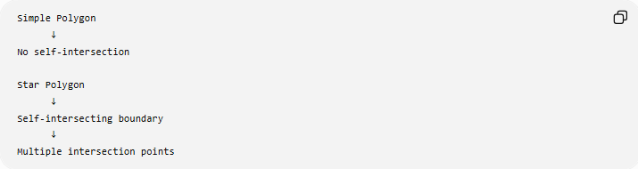
Simple Polygon
↓
No self-intersection

Star Polygon
↓
Self-intersecting boundary
↓
Multiple intersection points
This distinguishes a star polygon from an ordinary convex or concave simple polygon.

Types by Number of Vertices
# Source: AI Source: Provided by: [Data Path: Persons Table -> ID Column: 1, Name_En Column: Motasem Essam] -> From: [ChatGPT] on [7/25/2026]
General star polygons can be classified according to $n$.
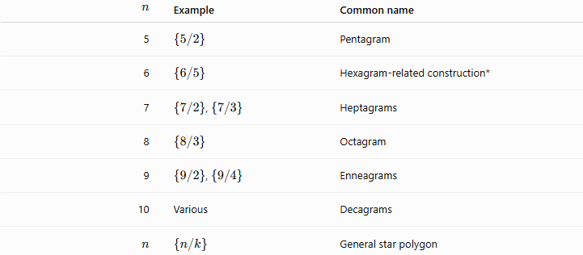
$$n$$ | Example | Common name
5 | $$\left\{5/2\right\}$$ | Pentagram
6 | $$\left\{6/5\right\}$$ | Hexagram-related construction*
7 | $\left\{7/2\right\}$, $\left\{7/3\right\}$ | Heptagrams
8 | $$\left\{8/3\right\}$$ | Octagram
9 | $\left\{9/2\right\}$, $\left\{9/4\right\}$ | Enneagrams
10 | Various | Decagrams
$$n$$ | $$\left\{n/k\right\}$$ | General star polygon
*Some constructions with composite $n$can produce multiple cycles or forms that are better treated separately, so the $gcd⁡\left(n , k\right)$condition must always be checked.

Types by Step Size
# Source: AI Source: Provided by: [Data Path: Persons Table -> ID Column: 1, Name_En Column: Motasem Essam] -> From: [ChatGPT] on [7/25/2026]
For a fixed $n$, changing $k$changes the star's structure.
For example, with $n=7$:
$$\left\{7/2\right\}$$
and:
$$\left\{7/3\right\}$$
produce different star polygons.
Thus:
$$\boxed{\text{Same number of vertices}+\text{different step size}=\text{different star polygon}}$$

Examples

Example 1: Identify the Star Polygon
# Source: AI Source: Provided by: [Data Path: Persons Table -> ID Column: 1, Name_En Column: Motasem Essam] -> From: [ChatGPT] on [7/25/2026]
Given:
$$\left\{7/2\right\}$$
we have:
$$n=7, k=2$$
Therefore, it is a:
$$\boxed{\text{Heptagram}}$$

Example 2: Determine Whether It Is One Continuous Polygon
# Source: AI Source: Provided by: [Data Path: Persons Table -> ID Column: 1, Name_En Column: Motasem Essam] -> From: [ChatGPT] on [7/25/2026]
Consider:
$$\left\{10/4\right\}$$
Calculate:
$$gcd⁡\left(10 , 4\right)=2$$
Since:
$$gcd⁡\left(10 , 4\right)≠1$$
the construction contains:
$$\boxed{2}$$
separate cycles rather than one continuous star polygon.

Example 3: Continuous Star Polygon
# Source: AI Source: Provided by: [Data Path: Persons Table -> ID Column: 1, Name_En Column: Motasem Essam] -> From: [ChatGPT] on [7/25/2026]
Consider:
$$\left\{9/2\right\}$$
Since:
$$gcd⁡\left(9 , 2\right)=1$$
the construction produces one continuous star polygon.
Therefore:
$$\boxed{\left\{9/2\right\}}$$
is a single regular star polygon.

Relationship with Related Concepts
# Source: AI Source: Provided by: [Data Path: Persons Table -> ID Column: 1, Name_En Column: Motasem Essam] -> From: [ChatGPT] on [7/25/2026]
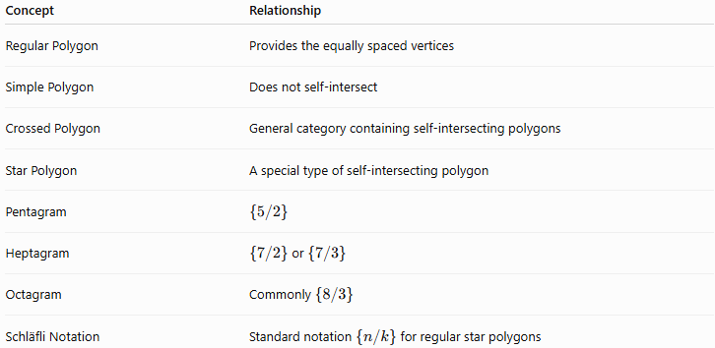
Concept | Relationship
Regular Polygon | Provides the equally spaced vertices
Simple Polygon | Does not self-intersect
Crossed Polygon | General category containing self-intersecting polygons
Star Polygon | A special type of self-intersecting polygon
Pentagram | $$\left\{5/2\right\}$$
Heptagram | $\left\{7/2\right\}$or $\left\{7/3\right\}$
Octagram | Commonly $\left\{8/3\right\}$
Schläfli Notation | Standard notation $\left\{n/k\right\}$for regular star polygons

General Star Polygon vs Regular Polygon
# Source: AI Source: Provided by: [Data Path: Persons Table -> ID Column: 1, Name_En Column: Motasem Essam] -> From: [ChatGPT] on [7/25/2026]
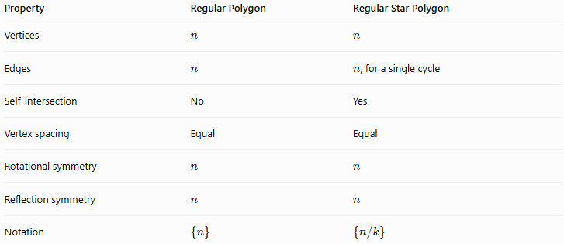
Property | Regular Polygon | Regular Star Polygon
Vertices | $$n$$ | $$n$$
Edges | $$n$$ | $n$, for a single cycle
Self-intersection | No | Yes
Vertex spacing | Equal | Equal
Rotational symmetry | $$n$$ | $$n$$
Reflection symmetry | $$n$$ | $$n$$
Notation | $$\left\{n\right\}$$ | $$\left\{n/k\right\}$$

General Star Polygon vs Crossed Polygon
# Source: AI Source: Provided by: [Data Path: Persons Table -> ID Column: 1, Name_En Column: Motasem Essam] -> From: [ChatGPT] on [7/25/2026]
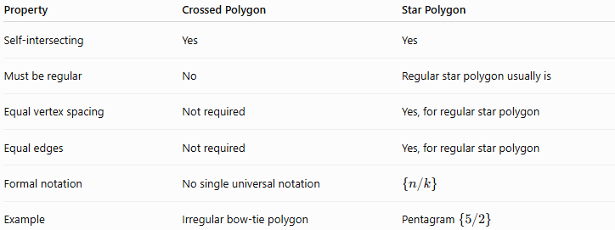
Property | Crossed Polygon | Star Polygon
Self-intersecting | Yes | Yes
Must be regular | No | Regular star polygon usually is
Equal vertex spacing | Not required | Yes, for regular star polygon
Equal edges | Not required | Yes, for regular star polygon
Formal notation | No single universal notation | $$\left\{n/k\right\}$$
Example | Irregular bow-tie polygon | Pentagram $\left\{5/2\right\}$
Thus:
$$\boxed{\text{Star Polygon}⊂\text{Self-Intersecting Polygon}}$$
when referring specifically to the regular mathematical star-polygon construction.

Taxonomy
# Source: AI Source: Provided by: [Data Path: Persons Table -> ID Column: 1, Name_En Column: Motasem Essam] -> From: [ChatGPT] on [7/25/2026]
For your knowledge-base hierarchy, I recommend:
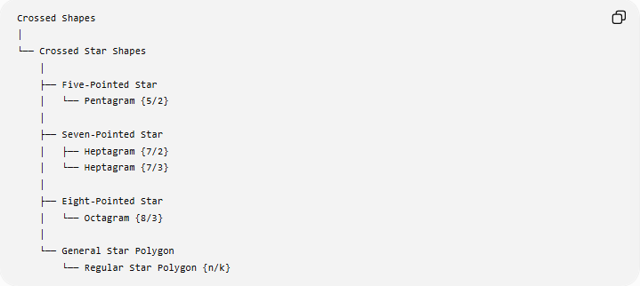
Crossed Shapes
│
└── Crossed Star Shapes
│
├── Five-Pointed Star
│ └── Pentagram {5/2}
│
├── Seven-Pointed Star
│ ├── Heptagram {7/2}
│ └── Heptagram {7/3}
│
├── Eight-Pointed Star
│ └── Octagram {8/3}
│
└── General Star Polygon
└── Regular Star Polygon {n/k}
However, for a more mathematically precise taxonomy, I recommend making General Star Polygon the parent concept rather than a sibling of the specific examples:
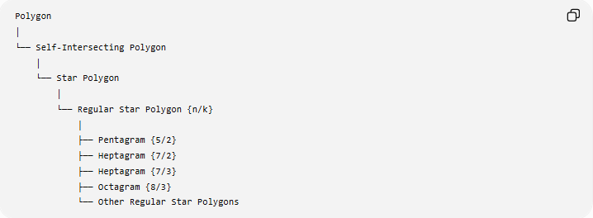
Polygon
│
└── Self-Intersecting Polygon
│
└── Star Polygon
│
└── Regular Star Polygon {n/k}
│
├── Pentagram {5/2}
├── Heptagram {7/2}
├── Heptagram {7/3}
├── Octagram {8/3}
└── Other Regular Star Polygons
This second structure is better for your mathematics knowledge base, because Pentagram, Heptagram, Octagram, etc. are specific examples of the general regular star-polygon family.

Real-World Applications
# Source: AI Source: Provided by: [Data Path: Persons Table -> ID Column: 1, Name_En Column: Motasem Essam] -> From: [ChatGPT] on [7/25/2026]
General star polygons are used in:
- Decorative geometric patterns.
- Architecture.
- Islamic geometric designs.
- Textile and tile patterns.
- Logos and symbols.
- Computer graphics.
- Mathematical visualization.
- Art and ornamentation.
- Computational geometry.

Advantages
# Source: AI Source: Provided by: [Data Path: Persons Table -> ID Column: 1, Name_En Column: Motasem Essam] -> From: [ChatGPT] on [7/25/2026]
- Provides a unified framework for many star shapes.
- Makes it easy to classify stars using $n$and $k$.
- Demonstrates self-intersection clearly.
- Provides a systematic construction method.
- Connects regular polygons to star polygons.
- Introduces useful mathematical notation.

Limitations
# Source: AI Source: Provided by: [Data Path: Persons Table -> ID Column: 1, Name_En Column: Motasem Essam] -> From: [ChatGPT] on [7/25/2026]
- The term star polygon can be used differently in informal geometry.
- Not every visual "star" is a mathematical star polygon.
- Some $\left\{n/k\right\}$constructions split into multiple components when $gcd⁡\left(n , k\right)>1$.
- Area calculations require a specified convention.
- A general star-shaped symbol may have curved edges or unequal points and therefore may not satisfy the definition of a regular star polygon.

Key Points
# Source: AI Source: Provided by: [Data Path: Persons Table -> ID Column: 1, Name_En Column: Motasem Essam] -> From: [ChatGPT] on [7/25/2026]
- A General Star Polygon is a framework for describing regular self-intersecting star polygons.
- It is represented by:
$$\boxed{\left\{n/k\right\}}$$
- $n$= number of vertices.
- $k$= step size.
- A single continuous star polygon requires:
$$\boxed{gcd⁡\left(n , k\right)=1}$$
- The number of separate cycles is:
$$\boxed{gcd⁡\left(n , k\right)}$$
- Its basic rotational angle is:
$$\boxed{\frac{{360}^{∘}}{n}}$$
- Examples include:
$$\boxed{\left\{5/2\right\}=\text{Pentagram}} \\ \boxed{\left\{7/2\right\},\left\{7/3\right\}=\text{Heptagrams}} \\ \boxed{\left\{8/3\right\}=\text{Octagram}}$$

Conclusion
# Source: AI Source: Provided by: [Data Path: Persons Table -> ID Column: 1, Name_En Column: Motasem Essam] -> From: [ChatGPT] on [7/25/2026]
A General Star Polygon is the mathematical framework for constructing and classifying regular self-intersecting star polygons. Using the notation $\left\{n/k\right\}$, the number of vertices and the connection step can precisely describe different star structures. This makes it the appropriate general topic under which specific figures such as the Pentagram, Heptagram, and Octagram can be organized.
Would you like to continue with another specific crossed star shape, such as a heptagram or decagram?

